Hello there delegates, my name is Kübranur Bayraktaroğlu. I am a former student of Milli Piyango Anatolian High School. And I will be President Chairperson of the Sochum committee in MPALMUN'20. I'm more than excited to see you as a delegate in our Conference. While preparing for MPALMUN'20 we had some hard, frustrating times but I'm pretty sure it will be more than worth it. We are ready for a beneficial and entertaining time ! Are you ready ? By the way if you have any questions do not hesitate to contact us.

Kübranur Bayraktaroğlu President Chairperson [kubranur_bayraktaroglu@live.nl](mailto:kubranur_bayraktaroglu@live.nl)

Introduction to the Committee

The Social, Cultural and Humanitarian Affairs Committee (SOCHUM) is the third committee of the six specialized subcommittees of the United Nations General Assembly. It was established after the development of the Universal Declaration of Human Rights in 1948.

Year after year, the General Assembly allocates to its Social, Humanitarian and Cultural Affairs Committee, agenda items relating to a range of social, humanitarian affairs and human rights issues that affect peoples all over the world.

An important part of the Committee’s work focuses on the examination of human rights questions, including reports of the special procedures of the newly established Human Rights Council. The Committee also discusses the advancement of women, the protection of children, indigenous issues, the treatment of refugees, the promotion of fundamental freedoms through the elimination of racism and racial discrimination, and the promotion of the right to self- determination.

**Topic: Gene exchange**

1. **Introduction**

Genetic technologies —the ability to manipulate and transform the properties of cells, seeds, microbes, insects, plants, animals and even humans—are pushing the frontiers of science and offers us new hope for disease control and cure. This field has come a long way since Gregor Mendel, the father of genetics, first postulated the rule of heredity in the 1850s. Genetic technologies are changing the way we produce food, improving crop yield and preventing catastrophic losses from droughts, floods and pests. They also are offering new solutions for fighting cancer and many hereditary diseases, improving quality of life and life expectancy. In addition, genetic technologies are increasingly used in criminal justice systems to exonerate the innocent and convict the guilty. Such technologies, moreover, have given rise to genetic genealogy, allowing people to find their ethnic roots.

While the upsides of genetic technologies are promising, we also need to consider their downside risks. Access to gene therapies to combat diseases, for example, may be limited to those who can afford them, potentially increasing inequality in health outcomes within and across countries.

Genomic research that serves to identify pre-existing conditions can potentially deprive patients from health insurance and medical care. Genetic technologies may exacerbate productivity gaps in agriculture, disadvantaging small farmers, especially in developing countries, who cannot access or afford genetically modified seeds. Moreover, there can be unintended health consequences of genetically modified crop production, including increased risks of contamination and loss of biodiversity.

The downside risks can be even uglier. Genetic modifications can potentially lead to the production of “designer babies” and super-humans and fundamentally alter the human species. Genomic research can be weaponized to target and harm specific population groups. The legal, ethical and moral boundaries of using genetic technologies are increasingly unclear, creating opportunities for their misuse and abuse. Weighing potential benefits against risks thus remains an urgent challenge.

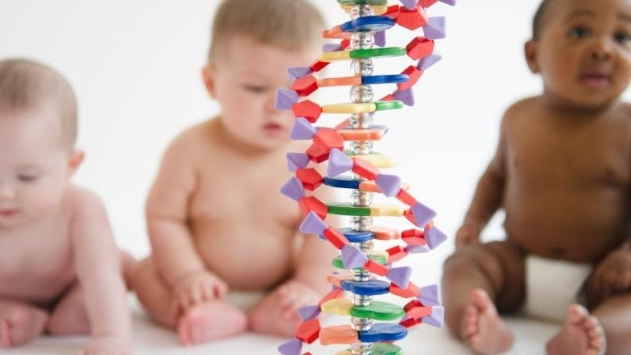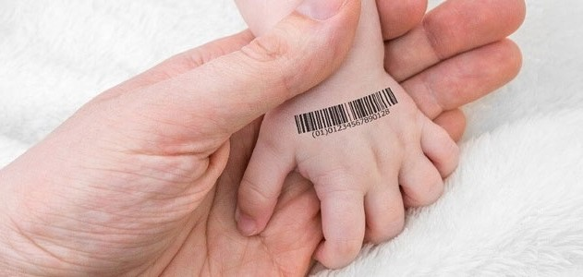

*What is gene exchange ?*

Gene exchange is changing the DNA of a person. It may be changed by humans and a natural way. In the microbial world, the genetic exchange might occur via either an asexual or a sexual process; Meanwhile, in higher plants and animals, it is usually a sexual process yet it may also rarely be the result of a viral infection. Whatever the mechanism of genetic exchange, the final result is an organism-or cell-with an altered genotype. The newly acquired genes could be either useful or detrimental to the organism. Seeing that genetic exchange continues to play a major role in determining how medicine is practiced, it is important to understand how genetic exchange occurs utilizing microbial donors and vectors.

*What is genome editing ?*

It's a kind of genetic engineering. DNA is inserted, replaced, or removed from a genome which uses artificially engineered nucleases or 'molecular scissors'. The nucleases make specific double-strand breaks at desired places in the genome. The cell’s own mechanisms fix the induced break- or breaks- by natural processes.

*What is CRISPR ?*

CRISPR is a term which is used in microbiology. It stands for Clustered Regularly-Interspaced Short Palindromic Repeats. These are natural segment of the genetic code which are found in prokaryotes- most bacterias have it-

CRISPR has plenty of short repeated sequences. These sequences are part of an adaptive immune system for prokaryotes. It let them remember and counter other organisms that prey on them-such as bacteriophages.

They have the potential to modify the genes of almost any organism. They are part of a tool allowing precisely targeted cutting and insertion of genes in genetic modification (GM). Work is underway to find how they can be used to attack virus diseases in humans.

1. **Current situation**

*Advancing human research*

Technological breakthroughs are lowering the cost of gene sequencing and editing, but gene therapies are still too expensive for most people. The cost of sequencing genes has declined dramatically—from nearly $9 million in 2007 to just $1,100 per genome in 2017—due to a revolutionary technology called Next Generation Sequencing. This drastic reduction in cost, though still prohibitively expensive for average income-earners in many developing

countries, has made sequencing and studying genes feasible for many countries. It has encouraged competition among countries to establish themselves as leaders in genomics, pursuing a range of objectives. While countries are prioritizing genomic research, international cooperation is also playing a critical role. The Human Heredity and Health in Africa (H3Africa) initiative, an example of successful collaboration in genetic research, directs funding from the National Institutes of Health (NIH) and the Wellcome Trust to research sites across Africa that study genomics, environmental determinants of common illnesses, disease susceptibility and drug responses in African populations.

**Countries establishing themselves as leaders in genomics: select projects and their objectives**

|  |  |  |
| --- | --- | --- |
| **Country Initiative Objective** | | |
|  | | |
| Australia | Australian Genomics Health Futures Mission | Develop national standards and protocols to enhance data gathering and analysis; promote the value of genomics to the broader community; and encourage government partnerships with philanthropists and businesses |
| China | 100,000 Genome Project | Study how Chinese population transform from health to disease, environmental impacts, and the interactions between environmental factors and genes, and its influence on people’s health |
| Estonia | Personalized Medicine Programme | Develop genotypes that will enable personalized reports for use in everyday medical practice through the national e-health portal |
| France | France Génomique 2025 | Integrate genomic medicine into routine patient care and establish a genomic medicine industry to fuel economic growth. By 2020, France aims to have increased its annual sequencing capacity to 235,000 genomes, of which 175,000 are to come from cancer patients, and the remaining 60,000 from rare disease patients |
| Japan | Initiative on Rare and Undiagnosed Diseases | Develop innovative drug candidates by targeting novel, single pathological mutations, apply new NGS-based genome analyses to cases that remain unsolved, and facilitate international data sharing |
| Saudi Arabia | Saudi Human Genome Program | Study more than 5,000 inherited diseases using more than 10,000 samples from Saudi patients with inherited diseases that resulted in identi cation of more than 2,000 variants underlying the diseases |
| Turkey | Turkish Genome Project | Sequence the genomes of 100,000 Turkish nationals and increase that number to 1 million genomes by 2023 |
| United Arab Emirates | United Arab Emirates— Dubai Genomics | Sequence all of its 3 million residents. Dubai Genomics is one of numerous projects within the Dubai Future Foundation’s “Dubai 10X Initiative,” launched to catapult the UAE 10 years ahead of the rest of the world |
| United Kingdom | 100,000 Genome Project | Incorporate genome sequencing in routine healthcare through the Genomic Medicine Service (GMS). Sequenced 71,095 whole genomes |
| United States | All of Us Research Program | Glean health and wellness data from 1 million or more Americ |

*He Jiankui affair*

The He Jiankui affair is a scientific and bioethical circumstance which concerns the use of gene- editing technique in human cases following the first use by Chinese scientist He Jiankui, making the first genome-edited babies in 2018. The affair led to legal and ethical controversies with an indictment of He and his two collaborators, Zhang Renli and Qin Jinzhou.

In this study guide we mentioned, everyone gets easily access to gene-editing kits and the techniques how to use it people do test without anyone knowing about. Like the development of GMO's, In November 2018, He Jiankui announced that he had edited two human embryos, attempting to disable the gene for CCR5, which codes for a receptor that HIV uses to enter cells. He said that twin girls, Lulu and Nana, had been born a few weeks earlier. He said that the girls still carried functional copies of CCR5 along with disabled CCR5 (mosaicism) and were still vulnerable to HIV. The work was widely condemned as unethical, dangerous, and premature.

In May 2019, lawyers in China reported, in light of the purported creation by Chinese scientist He Jiankui of the first gene-edited humans, the drafting of regulations that anyone manipulating the human genome by gene-editing techniques, like CRISPR, would be held responsible for any related negative consequences. A cautionary perspective on the possible blind spots and risks of CRISPR and related biotechnologies has been recently discussed, focusing on the stochastic nature of cellular control processes.

*Gene-edited monkeys*

In January 2019, scientists in China reported the creation of five identical cloned gene-edited monkeys,which use the same cloning technique that was used with Zhong Zhong and Hua Hua – the first ever cloned monkeys - and Dolly the sheep, and the same gene-editing Crispr-Cas9 technique allegedly used by He Jiankui in creating the first ever gene-modified human babies Lulu and Nana. The monkey clones were made in order to study several medical diseases.

*Duchenne muscular dystrophy (DMD) cure at pigs*

Duchenne muscular dystrophy (DMD) is one of the most common and most devastating muscular diseases, greatly reducing patients’ quality of life and life expectancy. Now, researchers in Germany have been able to use the CRISPR gene-editing tool to correct the condition in pigs, bringing the treatment ever closer to human trials.

A protein called dystrophin is necessary for muscles to regenerate themselves, but people with DMD have a genetic mutation that removes the gene producing dystrophin. That means that affected children usually begin to show symptoms of muscle weakness by age five, lose the ability to walk by about age 12, and rarely live through their 30s as their heart muscles give out.

Because it’s a genetic condition, DMD is a prime target for treatment with the gene-editing tool CRISPR. In experiments in pigs, the researchers on the new study used CRISPR to correct the faulty dystrophin gene. That allowed the pigs to once again produce dystrophin proteins – although they were shorter than usual, they were still stable and functional. That improved the animals’ muscle function and life expectancy, and made them less likely to develop an irregular heartbeat.

*Genetically modified organism (GMO)*

A genetically modified organism (GMO) is any organism whose genetic material has been altered using genetic engineering techniques. A wide variety of organisms have been genetically modified (GM), from animals to plants and microorganisms. Genes have been transferred within the same species, across species (creating transgenic organisms) and even across kingdoms. New genes can be introduced, or endogenous genes can be enhanced, altered or knocked out. Recent advancements using genome editing techniques, notably CRISPR, have made the production of GMO's much simpler.

Many objections have been raised over particularly their commercialization. Many of these involve GM crops and whether food produced from them is safe and what impact growing them will have on the environment. Other concerns are the objectivity and rigor of regulatory authorities, contamination of non-genetically modified food, control of the food supply, patenting of life and the use of intellectual property rights. Although there is a scientific consensus that currently available food derived from GM crops poses no greater risk to human health than conventional food, GM food safety is a leading issue with critics. Gene flow, impact on non-target organisms and escape are the major environmental concerns. Countries have adopted

regulatory measures to deal with these concerns. There are differences in the regulation for the release of GMOs between countries, with some of the most marked differences occurring between the US and Europe. Key issues concerning regulators include whether GM food should be labeled and the status of gene edited organisms.

One of the key issues concerning regulators is whether GM products should be labeled. The European Commission says that mandatory labeling and traceability are needed to allow for informed choice, avoid potential false advertising and facilitate the withdrawal of products if adverse effects on health or the environment are discovered. The American Medical Association and the American Association for the Advancement of Science say that absent scientific evidence of harm even voluntary labeling is misleading and will falsely alarm consumers. Labeling of GMO products in the marketplace is required in 64 countries. Labeling can be mandatory up to a threshold GM content level (which varies between countries) or voluntary. In Canada and the US labeling of GM food is voluntary, while in Europe all food (including processed food) or feed which contains greater than 0.9% of approved GMOs must be labelled. In 2014, sales of products that had been labeled as non-GMO grew 30 percent to $1.1 billion.

*Online kits*

CRISPR has been so common these days that there are CRISPR kits sold online with videos how to use it. This means that everyone could easily work with these kits, which could lead to either good or bad results.

Inside the kits:

* LB Agar
* LB Strep/Kan/Arabinose Agar
* Glass bottle for pouring plates
* 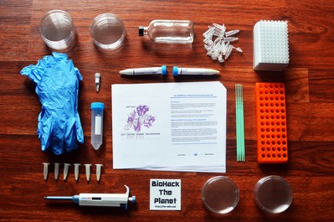Non-pathogenic E. coli bacteria
* Inoculation Loops/Plate Spreader
* 10-100uL variable volume adjustable pipette(1uL increments)
* Box of 96 Pipette Tips
* 14 Petri Plates
* Micro centrifuge tube rack
* Nitrile Gloves
* Micro centrifuge tubes
* 50mL Tube for measuring
* Bacterial transformation buffer 25mM CalCl2, 10% PEG 8000
* LB Media for transformation recovery
* Cas9 plasmid
* gRNA plasmid
* Template DNA

1. **Past UN actions**

*Human genome editing registry*

At 6 January 2020 World Health Organization (WHO) published the human genome editing registry. Seeing that everyone who is interested in genome editing could easily have access to it, there was need for a registry. The Committee agreed on a phased approach, with an initial focus on clinical applications and subsequent efforts to incorporate relevant basic research on human embryos and germ line cells. The Committee made a special search filter so they can identify clinical trials using genome editing tools.

1. **Conclusions**

the He Jiankui affair it could be too late to stop someone. But this can go both ways either it could cause to something good or something bad. But what are these good and bad things ?

The good

Genetic technologies are offering new solutions for disease control, prevention and cure. They are now being used to diagnose and treat complex diseases such as heart disease, asthma, diabetes and cancer. Genetic technologies may also soon allow us to eradicate malaria, a major health menace in many developing countries.

The bad

The high price tag of many genetic technologies means that not everyone will benefit. The cost of gene therapies for rare diseases as approved in the United States and Europe can range from

$373,000 to $1 million per patient per year. While genomics is shaping the future of medicine, the research is often targeted for certain population groups in mind, especially wealthy people who possess the ability to pay.

In that committee you will discuss on possible solutions for gene exchange like we mentioned that before. We as a UNITED NATIONS SOCIAL CULTURAL AND HUMANITARIAN COMMITTEE have responsibility for solving World issues like that and we will solve it in that committee .

1. **Questions a resolution must answer**
   1. Where is the limit in genome editing ?
   2. What are the ethical rules of genome editing ?
   3. How can we prevent subterranean study ?
   4. Should everyone have access to these method ?
2. **Bibliography**

https://[www.atsu.edu/faculty/chamberlain/Website/Lects/GENEXCH.HTM](http://www.atsu.edu/faculty/chamberlain/Website/Lects/GENEXCH.HTM) https://en.m.wikipedia.org/wiki/CRISPR https://newatlas.com/medical/crispr-gene-editing-muscular-dystrophy-pigs/ https://[www.who.int/news-room/q-a-detail/human-genome-editing-registry](http://www.who.int/news-room/q-a-detail/human-genome-editing-registry) https://en.m.wikipedia.org/wiki/Josef_Mengele#Human_experimentation https://[www.the-odin.com/diy-crispr-kit/](http://www.the-odin.com/diy-crispr-kit/)

https://sustainabledevelopment.un.org/content/documents/955511_Soltau_CRISPR- Cas9%20_%20gene-editing%20technology%20takes%20off.pdf

**Topic: Illegal organ transplantation**

1. **Introduction**

According to the World Health Organization (WHO), illegal organ transplantation is removing organs from a body for the purpose of commercial transactions. Although this is illegal anywhere from %5 to %42 of transplanted organs are illegally purchased. These percentages are rising according to a report by Global Financial Integrity estimating that illegal organ transplantation generates profits between $600 million and $1.2 billion per year, with a span over many countries. There are criminal networks, that kidnap people for their organs. (Most of the kidnapped people are children or teenagers.) These people are taking to places with medical equipment to be murdered and take out their organs.

The shortage of organs is virtually a universal problem. In some countries, the development of a deceased organ donation program is hampered by sociocultural, legal and other factors. Even in developed countries, where rates of deceased organ donation tend to be higher than in other countries, organs from this source fail to meet the increasing demand. The use of live donors for kidney and liver transplantation is also practiced, but the purchase and sale of transplant organs from live donors are prohibited in many countries.

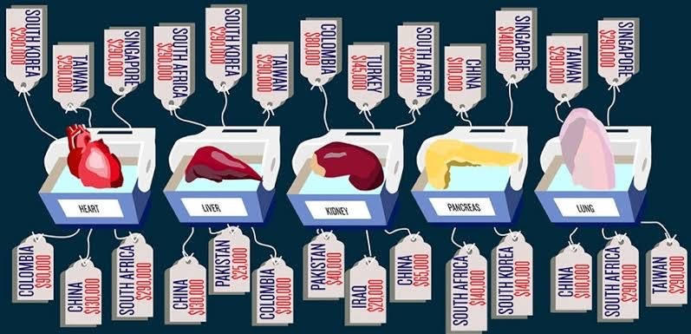

1. **Background and context**

*Iran*

In the 1980s, Iran had not only lack of legally donated kidneys but also subpar dialysis equipment in order to treat the growing segment of the population with end-stage renal disease (ESRD). But it had well-trained surgeons who are capable of performing organ transplants. That's why in 1988, the nation decided on a bold -debetable- strategy to eliminate the dangers that come with receiving an organ illegally:Making it legal for a living person to sell their kidney.

*The USA*

In 2016, legally donated organs were less than 10 percent of global need, according to a report from ONT-WHO,Global Observatory on Donation and Transplantation. In 2014, nearly 5 thousand Americans died while waiting for a kidney transplant and 3,668 were dropped off the list inasmuch as they became too sick to receive one- noted National Kidney Foundation (NKF)-

It's not that unexpected for people turn to the black market to save their live due to being given this substantial need. While the black market doesn’t exactly have any official ways to track it, the illegal trade of all organs generates between $840 million and $1.7 billion in each year and accounts for an estimated %10 transplanted organ, following by the report (2017) Global Financial Integrity (GFI).

*Egypt*

Egypt was regarded by WHO as one of the top five countries for illegal organ trade in 2010, for at that time, above %95 kidney transplants and at least %30 liver transplants were between non- related donors and recipients, which proved that payment was involved. Those catastrophe situations made Egypt to pass a law in 2010 banning commercial trade of organs as well as transplants between Egyptians and foreigners, apart from cases of husband and wife.

In 2012, then UN refugee agency chief, Antonio Guterres, said some migrants in Egypt’s Sinai Peninsula were being killed organs, and there have been reports that people who could not pay their debt were sold to the organ traffickers.

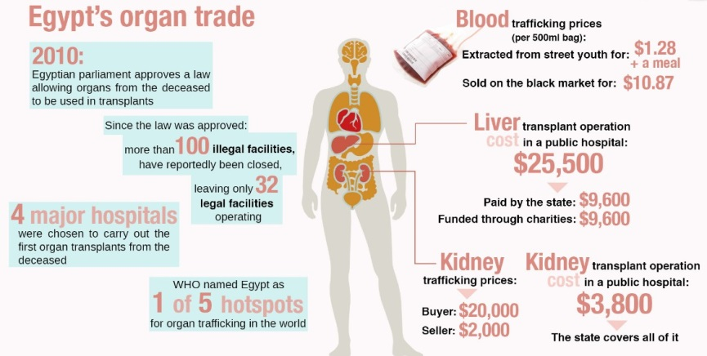

*China*

Organ transplantation in China has started ever since 1960s and also it is one of the largest organ transplant programmers in the world, with over 13,000 liver and kidney transplants a year in 2004. China is involved in innovative transplant surgery as well, like face transplantation which includes bones.

Reluctant organ harvesting is illegal under Chinese law; Nonetheless, under a 1984 regulation, it became legal to remove organs from executed criminals with permission of the criminal and relatives. By the 1990s it was condemned due to growing concerns about possible ethical abuses which arises from coerced consent and corruption led medical groups and human rights organizations.

*South Africa*

More than 100 illegal kidney transplants were performed at St. Augustine Hospital in South Africa in 2001 and 2002; most of the recipients came from Israel, while the donors were from Eastern Europe and Brazil. The police investigation in Brazil and South Africa revealed the existence of an international organ trafficking syndicate. These cases may involve human trafficking for the purpose of organ transplantation. Unlike cell tissues, no confirmed report on transplant organs being trafficked after their removal was found in this survey.

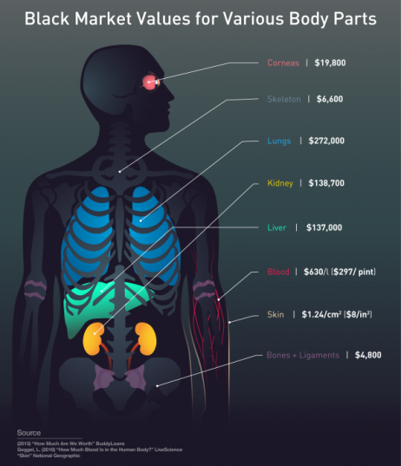

*India*

India was a commonly known organ-exporting country, where organs from local donors are regularly transplanted to foreigners through sale and purchase. Although the number of foreign recipients seems to have decreased after the enactment of a law banning the organ trade (the Human Organ Transplantation Act of 1994), the underground organ market is still existent and resurging in India. The Voluntary Health Association of India estimates that about 2000 Indians sell a kidney every year. The drop in foreign recipients in India was accompanied by an increase in the number of foreign recipients in other countries, such as Pakistan and the Philippines.

*Pakistan*

In Pakistan, according to the Sindhi Institute of Urology, approximately 2000 renal transplants were performed in 2005, of which up to two-thirds were estimated to have been performed on foreigners. 12 In the Philippines, data obtained from the Renal Disease Control Program of the Department of Health, National Kidney Transplant Institute, show that of the 468 kidney transplants in 2003, 110 were for patients from abroad. There is no comparable data for Egypt but a considerable number of patients from neighboring countries are believed to undergo organ transplantation there.

*Transplant Tourism*

The most common way to trade organs across national borders is via potential recipients who travel abroad to undergo organ transplantation, commonly referred to as “transplant tourism”. Although this term may be contentious as it disregards the patients’ desperate motives and fails to reflect ethical issues.

“Transplant tourism” involves not only the purchase and sales of organs, but also other elements relating to the commercialization of organ transplantation. The international movement of potential recipients is often arranged or facilitated by intermediaries and health-care providers who arrange the travel and recruit donors. The Internet has often been used to attract foreign patients. Several web sites offer all-inclusive “transplant packages” – the price of a renal transplant package ranges from US$ 70 000 to 160 000.

There are also facilitators in the recipients’ countries of origin. In Taiwan, China 118 patients who underwent organ transplants in China were questioned by their Department of Health, and 69 reported that their transplants were facilitated by doctors. Subsequently, the local authorities in Taiwan, China, have prohibited such activities. There have also been allegations that embassy officials of certain Middle Eastern countries have facilitated overseas commercial kidney transplants in Pakistan and the Philippines.

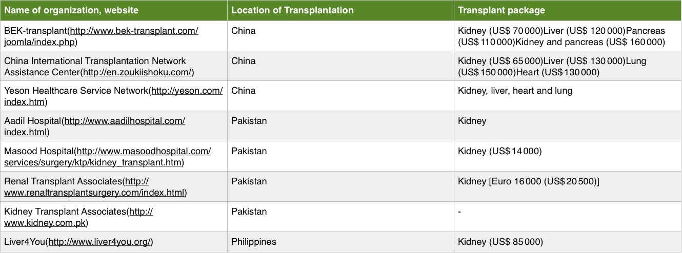

*Human Trafficking For Organs*

Organ trafficking victims, as with most human trafficking victims, are generally poor, vulnerable populations (United Nations, 2018). There are rare instances where victims are put under anesthetic and wake to find their organs missing or are murdered for their organs.

The exploitation of human beings for purposes of organ transplantation is also linked to other commodification practices, such as transnational commercial surrogacy, which hold special dangers for the rights and dignity of the world’s poorest and most vulnerable, and to broader questions of justice and rights that arise in the context of transplant tourism.

Available information on trafficking in persons for the removal of organs is incomplete and often unverified. Scholarly research in this area is not yet well-developed and anecdotal reports from civil society organizations and the media remain the primary source of information. Part of the problem lies in the clandestine nature of the trafficking. Even more so than other forms of trafficking in persons, those involved in trafficking in persons for the removal of organs (including victims) have very little incentive to come forward to researchers and criminal justice authorities with information and evidence. Victims are also unlikely to be identified through the multitude of channels that are now used to identify other victims of trafficking such as those subject to forced labour or sexual exploitation. Health-care providers who end up treating persons who have obtained organs abroad may be inhibited from sharing information with the authorities owing to concerns over patient privacy, their own obligations of confidentiality, uncertainty as to whether any laws have been breached or, indeed, their own complicity in the arrangement. Furthermore, definitional problems and confusion contribute to poor reporting and analysis and render comparisons between countries and between transplantation practices extremely difficult.

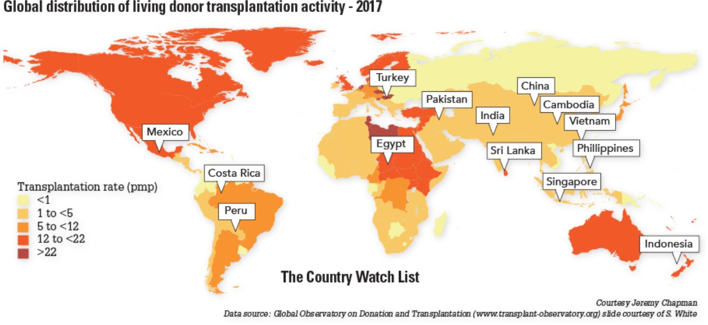

1. **Past UN actions**

The international organ trade has been recognized as a significant health policy issue in the international community. A World Health Assembly resolution adopted in 2004 urges Member States to “take measures to protect the poorest and vulnerable groups from ‘transplant tourism’ and the sale of tissues and organs”. Despite growing awareness of the issue, the reality of the international organ trade is not well understood due to a paucity of data and also a lack of effort to integrate the available information.

*ECOSOC Resolution July 2004*

Subject: Preventing, combating and punishing trafficking in human organs

1. Urges Member States, should they ascertain that such a phenomenon exists in their country, to adopt the necessary measures to prevent, combat and punish the illicit removal of and trafficking in human organs;
2. Encourages Member States to exchange experience in and information on preventing, combating and punishing the illicit removal of and trafficking in human organs;
3. Requests the Eleventh United Nations Congress on Crime Prevention and Criminal Justice to pay attention to the issue of the illicit removal of and trafficking in human organs;
4. Requests the Secretary-General of the United Nations, in collaboration with the States and organizations concerned and subject to the availability of extrabudgetary resources, to prepare a study on the extent of the phenomenon of trafficking in human organs for submission to the Commission on Crime Prevention and Criminal Justice at its fifteenth session.”

*The Declaration of Istanbul 2008*

The Declaration of Istanbul was drafted by over 150 representatives from 78 countries around the world to become the legal and professional framework for ethical practices of organ procurement and transplantation. The Declaration of Istanbul defined organ trafficking, transplant commercialism, and transplant tourism as well as gave specific guidelines for care, reimbursement, and recruitment of living donors. The revised 2018 edition of The Declaration of Istanbul further defines organ trafficking, specifically trafficking in persons for the purpose of organ removal, self- sufficiency in organ donation, and financial aspects of organ donation. Following the Declaration of Istanbul, the World Health Organization, the World Medical Association, and the European

*October 2011*

Trafficking in persons for the purpose of organ removal was on the agenda of the Working Group on Trafficking in Persons established by the Conference of Parties to the Organized Crime Convention at its fourth session, from 10 to 12 October 2011.

The Working Group recommended that States make better use of the Convention and Trafficking in Persons Protocol in combating trafficking in persons for the purpose of organ removal.

The Working Group recommended that States parties to the Convention should encourage relevant United Nations entities, including UNODC, to gather evidence-based data on trafficking in persons for the purpose of organ removal, including root causes, trends and modus operandi, with the aim of facilitating better understanding and awareness of the phenomenon while recognizing the difference between trafficking in organs, tissues and cells.

The Working Group also requested UNODC to develop a training module against trafficking in persons for the purpose of organ removal, and provide technical assistance, especially in regard to investigation, exchange of information and international legal cooperation.

*The United Global Report on Trafficking in Persons - 2018*

The United Nations Global Report on Trafficking in Persons (2018) states that the areas where human trafficking as a whole has decreased are countries that have adopted legislation, have detailed action plans, and are dedicated to identifying victims and perpetrators of trafficking. In regards to organ trafficking specifically, the United Nations (2018) highlights the importance of: coordination among United Nations entities in efforts against organ trafficking; taking on full implementation of provisions against organ trafficking; focusing on protection of vulnerable populations and preventing abuses of power; increasing efforts at identifying victims; and addressing international supply and demand and increasing awareness.

1. **Conclusions**

In this study guide we mentioned, organ trafficking is illegal in most of the counties around the world. But this doesn't stop people from it. Still today are there underground organ transplantations been done. Because buyers can't get an organ the legal way. But is this ethic ? While they get their illegal new organs there are people more sick than them waiting for an organ or the people that get kidnapped and killed for there organs is this fair to them ?

At this subject we want you to think of both ethical and in accordance to the law. We want u the have fruitful resolution for both the buyer and sellers of the organs.

We as a UNITED NATIONS SOCIAL CULTURAL AND HUMANITARIAN COMMITTEE have responsibility for solving World issues like that and we will solve it in that committee.

1. **Questions a resolution must answer**
   1. Should selling an organ with people's own permission be illegal
   2. What can be done against organ black market?
   3. Could legalizing an organ sale save lives?
   4. If organ trade were legal, what kind of ethical affairs would be taken into account?
   5. What are the other ways of making it easy for people to access to an organ in legal way?
2. **Bibliography**

https://en.m.wikipedia.org/wiki/Organ_trade <http://venturesafrica.com/egypt-crackdown-international-organ-traffickers/> https://futurism.com/neoscope/sale-human-organ https://en.m.wikipedia.org/wiki/Organ_transplantation_in_China https://[www.ohchr.org/Documents/Issues/Trafficking/A-68-256-English.pdf](http://www.ohchr.org/Documents/Issues/Trafficking/A-68-256-English.pdf)

https://[www.unodc.org/unodc/en/organized-crime/intro/emerging-crimes/organ-trafficking.html](http://www.unodc.org/unodc/en/organized-crime/intro/emerging-crimes/organ-trafficking.html)